1. Write a program to implement the method with out having any argument.

def add():

print('result=');

add()



1. Write a program to implement the method with Required argument.

def add(a,b,c):

print('result=',(a+b+c));

add(10,20,30)



1. Write a program to implement the method with Keyword argument.

def disp(a,b,c):

print('a=',a);

print('b=',b);

print('c=',c);

disp(c='Sample',a=10,b=20);

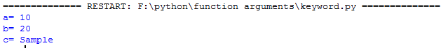

1. Write a program to implement the method with Default argument.

def disp(a,b,c,d=5,e=10):

print('a=',a);

print('b=',b);

print('c=',c);

print('d=',d);

print('e=',e);

disp(a=10,b='welcome',c=5,d=30);

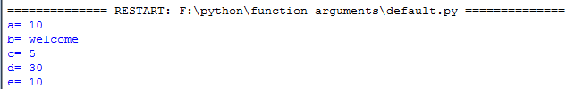

1. Write a program to implement the method with Variable-length argument.

def disp(a,\*b):

print('a=',a);

for i in b:

print('b=',i);

disp(10,20,30,40,50,60);

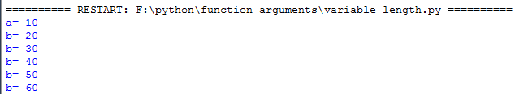

1. Write a program to implement the method with returning nothing.

def disp(a,b,c,d,e):

return

x=disp(32,10,15,56,45);

print('x=',x);



1. Write a program to implement the method with returning single value.

def disp(a,b,c,d,e):

return a

x=disp(32,10,15,56,45);

print('x=',x);



1. Write a program to implement the method with returning multiple values.

def disp(a,b,c,d,e):

return a,b

x,y=disp(32,10,15,56,45);

print('x=',x);

print('y=',y);



1. Write a program to add three numbers using anonymous function (lambda keyword)

add=lambda a,b,c:(a+b+c)

res=add(10,20,30);

print('res=',res);

